In this program a two dimension array of String represents a picture of letters/words. Your task is to translate the array into a String that represents the letters in the same order. Each String in the two dimensional array will either be a space (“ “) or an X (“X”).
The shape of each letter is given below in one of the three pictures. There will always be (a column of) blanks between each letter as shown in the following pictures.

All letters are seven rows high, but the width of each letter differ as shown.

The letters A B C D E F G H I J K L
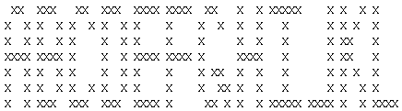
The letters M N O N P Q R S T U V
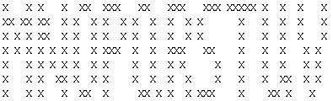
The letters W X Y Z
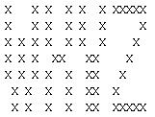

You have been given the LetterRecognition class which contains two methods. The first method is the getLetter method which has a single 2d String array as a parameter. This 2d String array contains a single letter which is returned as an upper case (capital) letter (String). The second method is the getWord method which has a single 2d String array as a parameter. This 2d String array may contain more than one letter. Each letter is separated by a single column of spaces. There are no (column of) spaces at the end of the word.

public class LetterRecognition
{
public String getLetter(String[][] block)
{
return "A";
}

public String getWord(String[][] blocks)
{
String ans = "IA";
return ans;
}
}

The student tester is shown below:

public class StudentTest extends junit.framework.TestCase
{
public void testLetterRecognition01()
{
LetterRecognition lr = new LetterRecognition();

assertEquals("A", lr.getLetter(let_A));
assertEquals("IA", lr.getWord(let_IA));
}

String[][] let_A = { {" ", "X", "X", " "},
{"X", " ", " ", "X"},
{"X", " ", " ", "X"},
{"X", "X", "X", "X"},
{"X", " ", " ", "X"},
{"X", " ", " ", "X"},
{"X", " ", " ", "X"} };

String[][] let_IA = { {"X", "X", "X", "X", "X", " ", " ", "X", "X", " "},
{" ", " ", "X", " ", " ", " ", "X", " ", " ", "X"},
{" ", " ", "X", " ", " ", " ", "X", " ", " ", "X"},
{" ", " ", "X", " ", " ", " ", "X", "X", "X", "X"},
{" ", " ", "X", " ", " ", " ", "X", " ", " ", "X"},
{" ", " ", "X", " ", " ", " ", "X", " ", " ", "X"},
{"X", "X", "X", "X", "X", " ", "X", " ", " ", "X"}};
}

